Lecture 06

**RPM-Install-Upgrade-Erase-Package-InLInux**

Mounting CD ROM

* $ mount /dev/cdrom <mount_point> --> by this way CD ROM can be manually mounted. “/dev/cdrom/” is default path for CD ROM.
* $ rpm -ivh <rpm_package> --> to install a package à ‘’I” means installation à “v” means verbos (display result on screen), à “h” hash, to make content short à hash Data base converts the junk during installation into “######” à that junk is not human readable.
* To check where and which files of a specific “rpm” packages are going to be copied during installation,
* $ rpm -qlp <rpm_package> → query list package
* 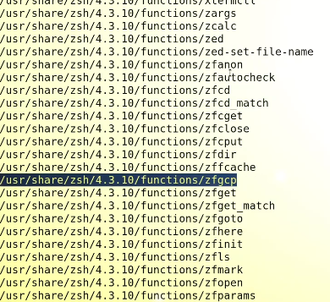
* To check files which were to be written during installation
* $ rpm -ivh zsh | wc -l à to display no of file copied to HDD during installation
* To check an installed package and the files it copied on different locations,
* $ rpm -ql <package_name>
* 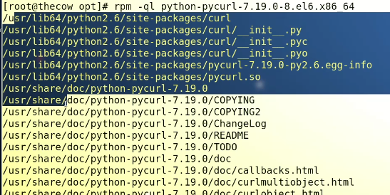
* $ rpm -ql <Package_Name> à to list all the information of an installed package.

**Uninstallation**

* $ rpm -e <package_name> à deletes all files related to “zsh”
* 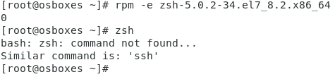
* Tip:- if during installation the error displays that it is already installed” à use “--force” flag to overwrite it forcefully à reinstalls it
* 

**Upgrading a package**

* Download latest version.
* [www.rpm.pbone.net](http://www.rpm.pbone.net) à for downloading lots of “rpm” packages,
* www.filewatcher.com
* www.rpmseek.com
* Tip:- To copy a package from CLI
* $ wget <link of the package> à “curl” is also CLI downloader
* 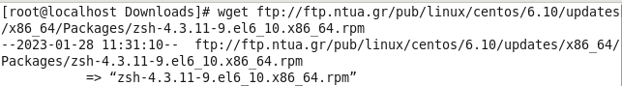
* To upgrade an installed package
* $ rpm -uvh <latest_version_package_name>
* 
* Package upgraded.
* Error dependencies
* 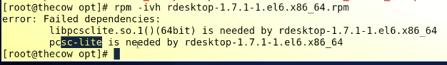
* In this case first we need to install that specific dependency à this is todays task

**How rpm works**

* “rpm” maintains a Data Base and lists all the installed packages information à and displays results and information against all the commands “-qa” “-ql” “-qi” à during installation a packages copies all the files in HDD and also lists its information in rpm DB file.
* Location of rpm DB file à /var/lib/rpm/
* 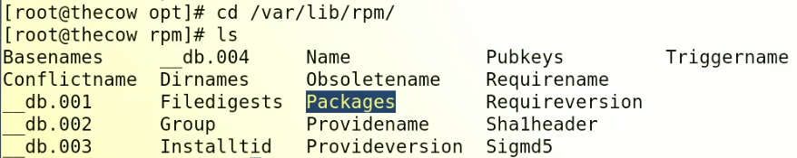
* “Packages” file has all the information related to the rpm packages
* If it is corrupt à all the commands related to rpm will stop working à how to fix it ?
* We can fix it by a command,
* $ rpm --rebuilddb